**Beaches:**

Russian Beach

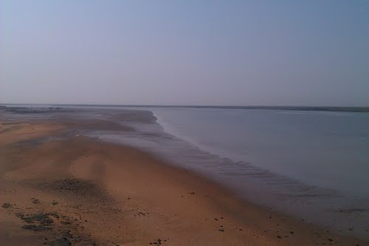

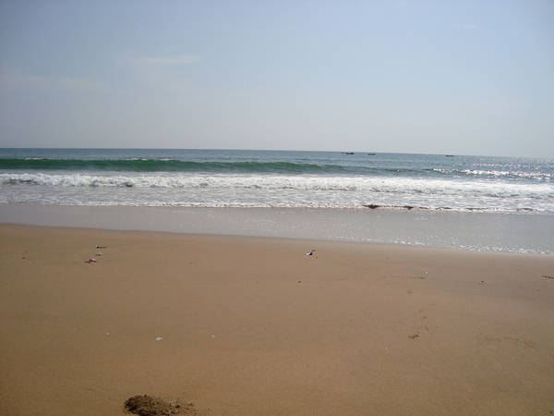

Russian beach is in Mazar Rd Bin Qasim Town, Karachi. Pakistan Steel Mill was created with the help of Russia. This part of the land was selected as a leisure spot for Russian Engineers who came to Pakistan as part of the technical swap, but it doesn’t happen. This beach is very striking for those people who have some interest in fishing. It has too many beautiful huts where you can go with your family for snorkeling and scuba diving.If your boring schedule is making you feel exhausted and you are enthusiastically looking forward to getting free from the rat race, then it’s time for you to allow yourself a break and have fun on the beaches of Karachi.

Cape Monze

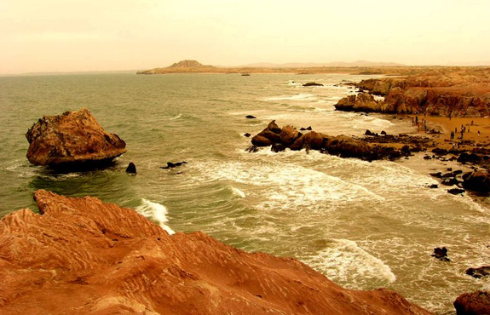

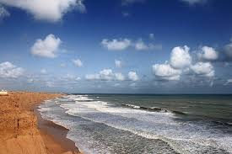

**Ras Muari**, often referred to as Cape Monze, is a beach located off the shore of the Arabian Sea in Karachi. It stretches from the village of Mubarak to Yousuf Goth (Pacha) in West Karachi, Sindh, Pakistan.

Turtle Beach

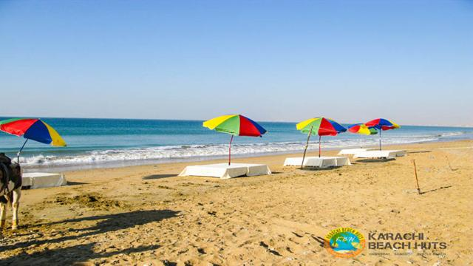

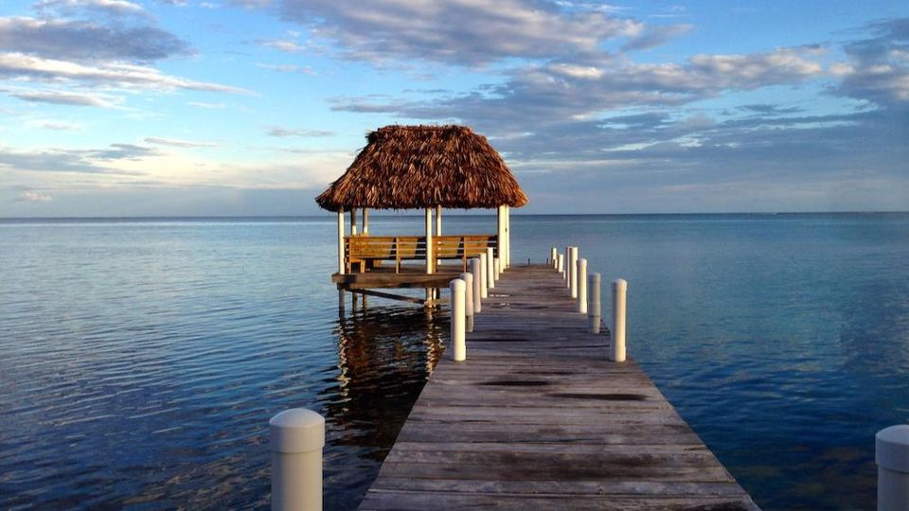

Turtle beach is very famous tourist spot and picnic place in karachi.its a naturally sandy beach where no rocks and reefs. its located between hawksbay and sandspit. In summers, rare species of Green and Olive Ridley Turtles come to lay eggs in the Southwest beaches of Karachi, specially to the Sandspit Beach and the Hawksbay Beach. The name "Sandspit" itself refers to pits made by Turtles to burry eggs. These pits can be obsereved on the beachside during summer months. During the nesting period, Lucky ones can see these Turtles creeping in and out of the sea mostly after the sunset. These turtles form tractor like tracks, as shown in the photographs, visible all around alongside the beach. World Wildlife Fund (WWF) has also set-up a Wetland Center at Sandspit Beach to dissiminate awareness about turtle conservation methods. These beaches also host various other marine species, to name the few are Algae, Snails, and Crabs.

Sandspit Beach

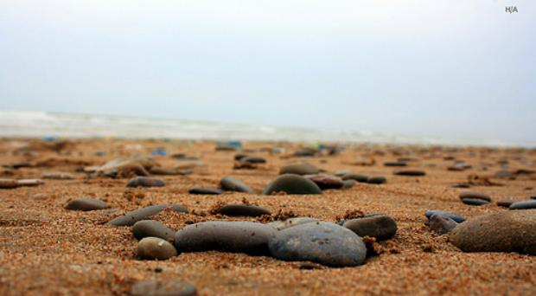

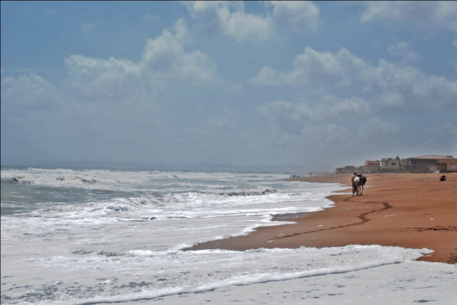

The Sandspit Beach is also a nesting ground for Green and Olive Ridley Turtles, implemented by the Sindh Wildlife Department over the past two decades. Nesting takes place in early winter months. In recent years the WWF-Pakistan has also become involved in turtle conservation activities by establishing a Wetland Centre at the Sandspit beach.

Clifton Beach

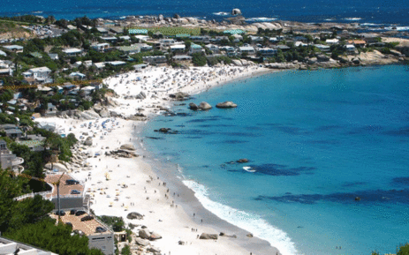

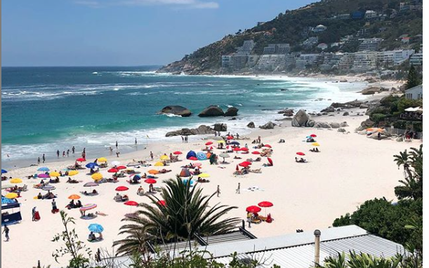

**Clifton Beach** or most commonly known as **Seaview** in Karachi, Sindh, Pakistan located on the Arabian Sea. It stretches from Karachi to Ormara (Balochistan). In 2003 it was affected by an oil spill and polluted with oil.

Hawk's Bay

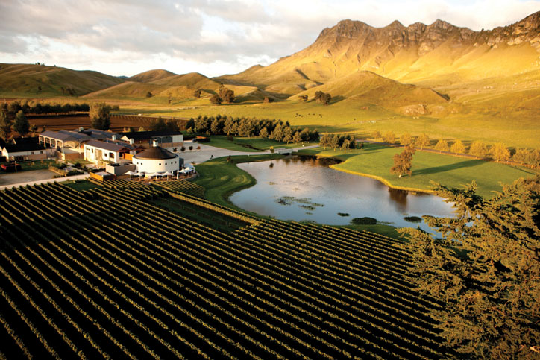

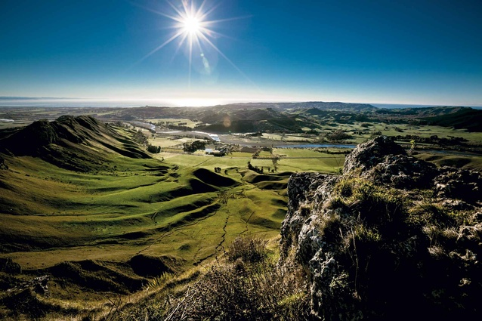

**Hawke's Bay** Or **Hawkesbay** is a beach in Karachi, Sindh, Pakistan located 20km at south-west of Karachi. This beach is named after Bladen Wilmer Hawke, who owned a beach house here in 1930s. Hundreds of people visit here daily for swimming, camel and horse riding and for vacations.